Project Design Phase Solution Architecture

Date | 17 February 2025
Team ID | LTVIP2026TMIDS91693
Project Name | Exploratory Analysis of Rain Fall Data in India for Agriculture
Maximum Marks | 4 Marks

Solution Architecture:
Solution architecture is a complex process – with many sub-processes – that bridges the gap between business problems and technology solutions. Its goals are to:

- Find the best tech solution to solve existing business problems.
- Describe the structure, characteristics, behaviour, and other aspects of the software to project stakeholders.
- Define features, development phases, and solution requirements.
- Provide specifications according to which the solution is defined, managed, and delivered.

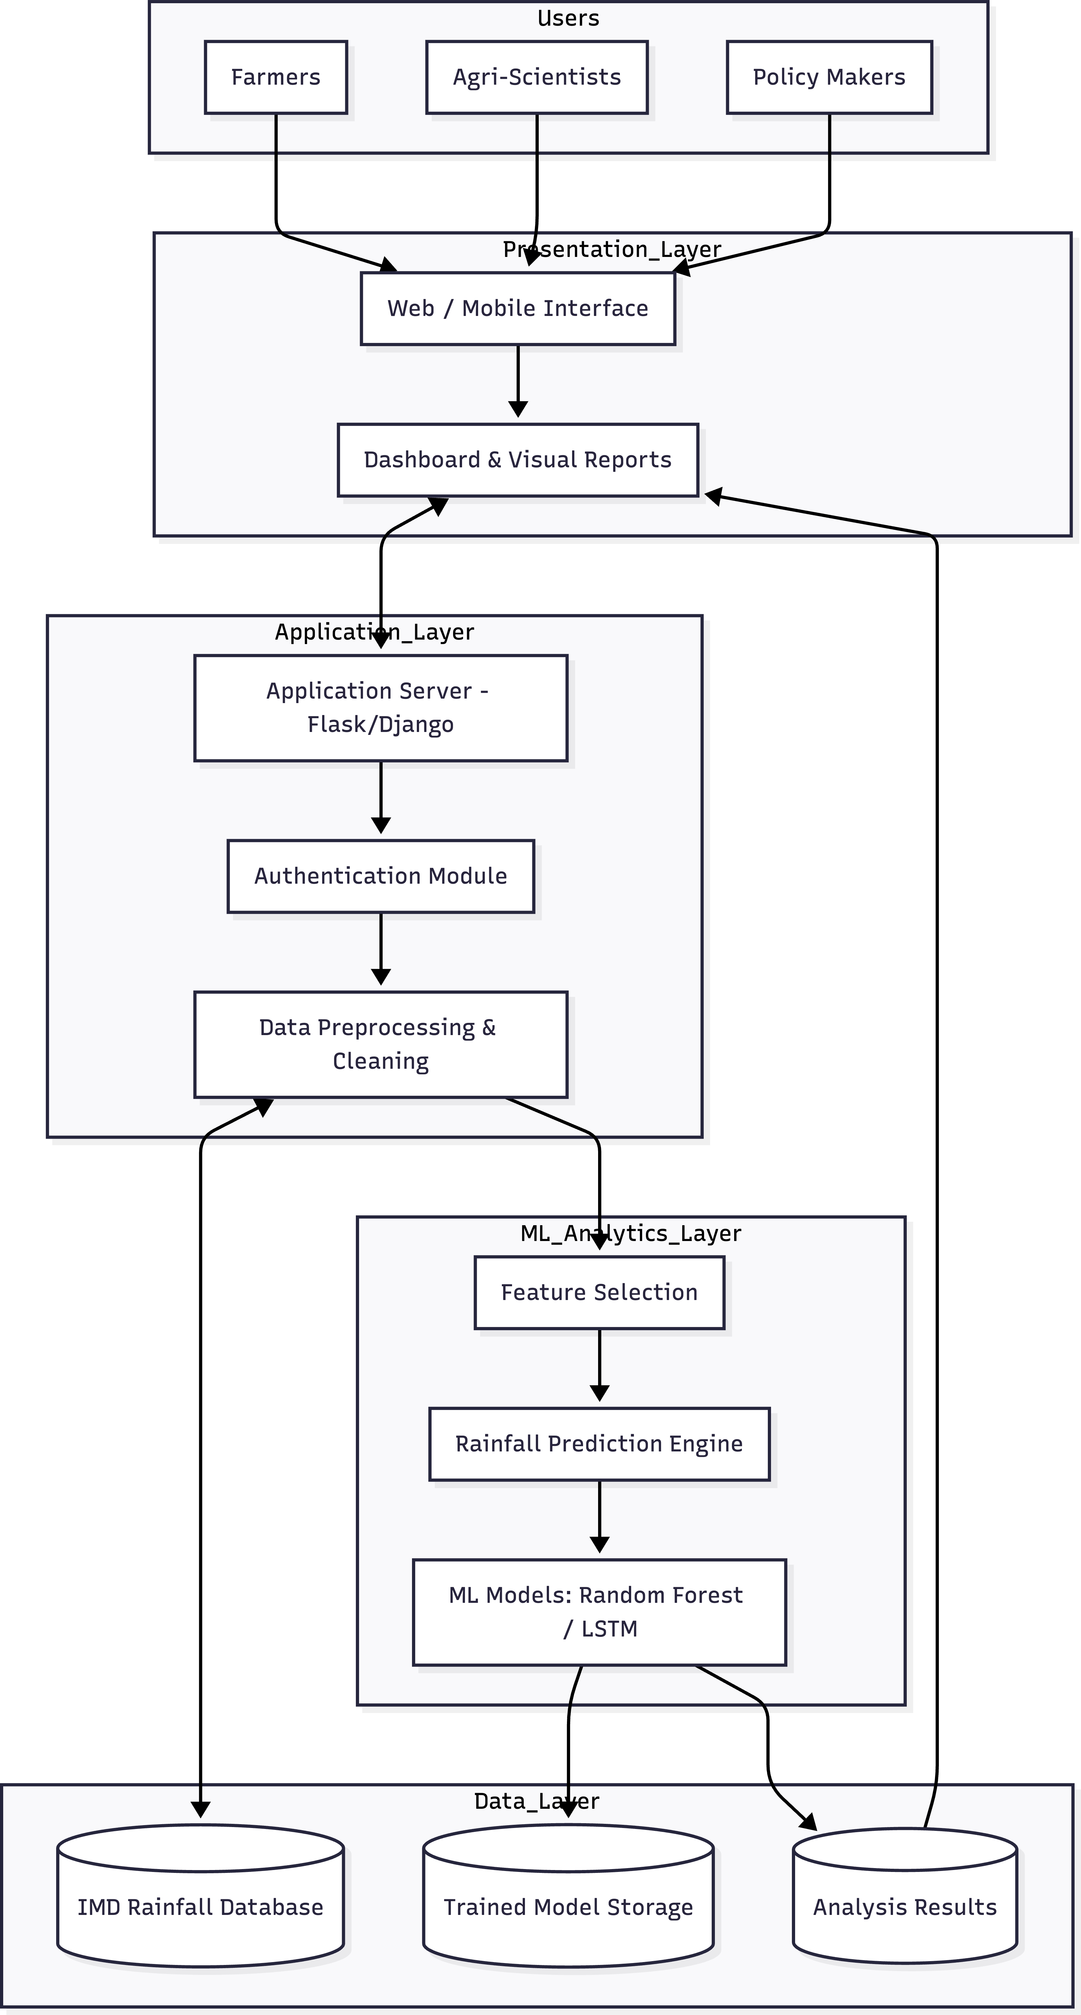

To explain the solution architecture for your project, "Exploratory Analysis of Rainfall Data in India for Agriculture," you can use the following descriptive text. This explanation follows the standard layered approach used in software engineering to bridge business problems with technical solutions.

Architecture Flow Explanation
- User Access Layer: The system is designed for three primary user groups: Farmers, Agricultural Scientists, and Policy Makers. They interact with the system through a Web or Mobile Interface to access dashboards and localized rainfall reports.

- Presentation Layer: This layer serves as the entry point where users can log in securely. It transforms complex data into intuitive visual formats, such as rainfall maps and trend charts, allowing users to input their specific region or crop type to view tailored prediction results.

- Application Layer: Operating as the "brain" of the system, this layer handles the core logic using frameworks like Flask or Django. It manages the Authentication Module for security and performs Data Preprocessing, which involves cleaning raw historical rainfall data and handling missing values to ensure high-quality analysis.

- Analytics & Machine Learning Layer: In this layer, the system performs Feature Selection to identify which variables (like specific months or regional indicators) most impact agricultural outcomes. The Prediction Engine then utilizes Machine Learning models—such as Logistic Regression or Random Forest—to process the data and calculate the probability of rainfall success or drought risks.

- Data Management Layer: This foundational layer acts as the central repository. It stores the Rainfall Database (historical IMD data), the Trained Model Storage (saved algorithms), and the final Prediction Results for future retrieval and comparative studies.

- Insight Generation: Finally, the system uses a Report Generation module to produce actionable insights. These reports support data-driven decision- making, helping stakeholders move away from intuition toward evidence- based agricultural planning.

Key Architectural Benefits
  - Modularity: By separating the UI, logic, ML, and data layers, the system is easier to maintain and update.
  - Scalability: The architecture is cloud-ready, meaning it can handle increasing amounts of rainfall data as more Indian states or districts are added.
  - Sustainability: The layered approach allows for easy upgrades to machine learning models as newer, more accurate algorithms become available.

